# **NAAN MUDHALVAN PROJECT**

Project Title: Comprehensive Guide to Apple iPhone 13 pro: Features, Benefits, and Usage

Team Members

|  |  |  |  |
| --- | --- | --- | --- |
| **s.no** | **Name** | **Naan Mudhalvan- ID** | **E Mail-ID** |
| 1. | R. Umashankar | au723921243051 | [umaraji6383@gmail.com](mailto:umaraji6383@gmail.com) |
| 2. | P. Saravanakumar | au723921243501 | [saravana2034866@gmail.com](mailto:saravana2034866@gmail.com) |
| 3. | M. Poovarasan | au723921243044 | [poovarasan2004mp@gmail.com](mailto:poovarasan2004mp@gmail.com) |
| 4. | G. Sriram | au723921243302 | [sriram13603@gmail.com](mailto:sriram13603@gmail.com) |

ARJUN COLLEGE OF TECHNOLOGY- COIMBATORE

DEPARTMENT OF

ARTIFICIAL INTELLIGENCE & DATA SCIENCE

Abstract:

As a ServiceNow user, I want to publish a detailed Knowledge Article for an item listed in the Service Catalog, so that customers can easily find comprehensive information, instructions, and support related to the products they are interested in purchasing Iphone 13 pro.

**Implementation**

**Step 1 :** Sign in to ServiceNow.

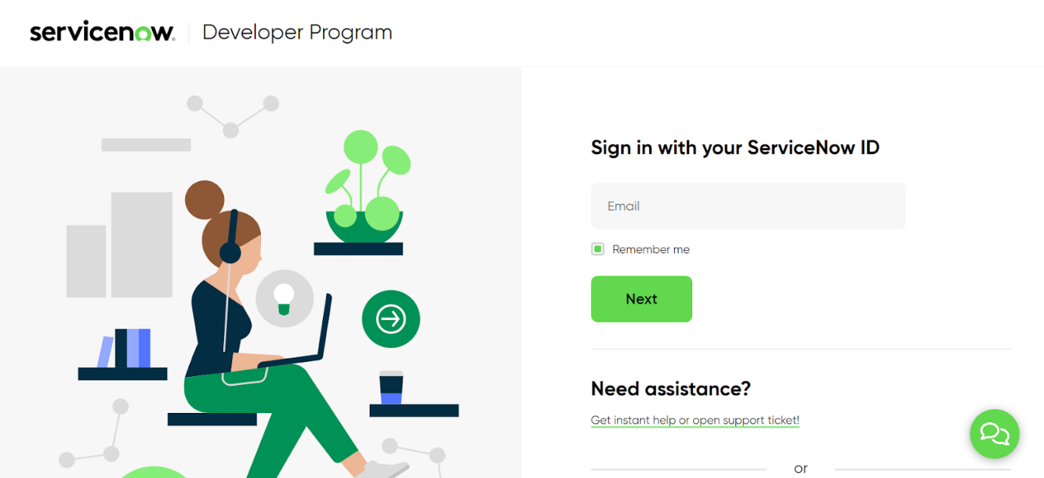

**Step 2 :** Sign up for a developer account on the ServiceNow Developer site “[https://developer.servicenow.com](https://developer.servicenow.com/)”.

**Step 3 :** Once logged in, navigate to the "Personal Developer Instance" section.

Click on "Request Instance" to create a new ServiceNow instance.

**Step 4 :** Fill out the required information and submit the request.

**Step 5 :** You'll receive an email with the instance details once it's ready.

**Step 6 :**Log in to your ServiceNow instance using the provided credentials.

Now you will navigate to the ServiceNow.

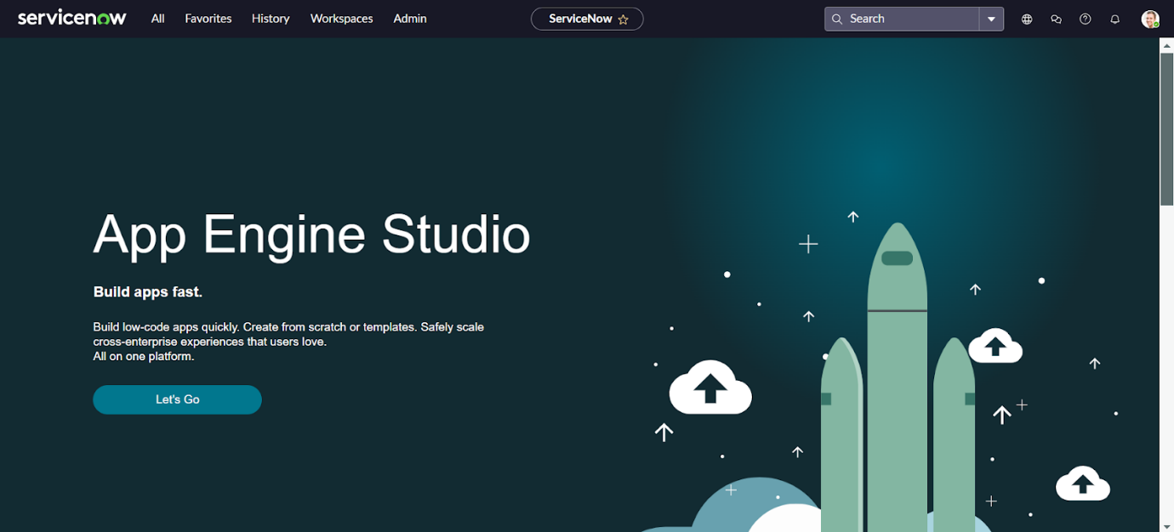

**Step 7 :** Open “users” >> New.

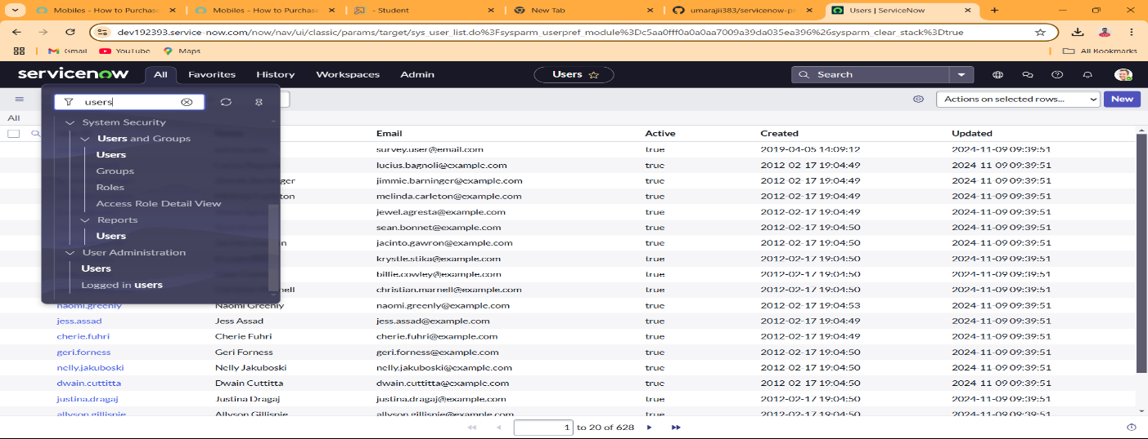

**Step 8 :** Fill the details of the table with fields as below >> Save.

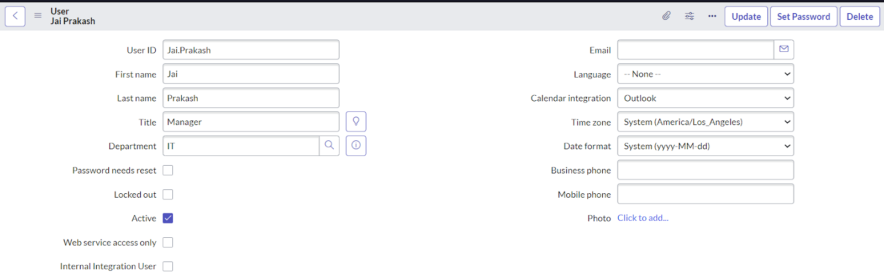

**Step 9 :** Open “groups” >> New.

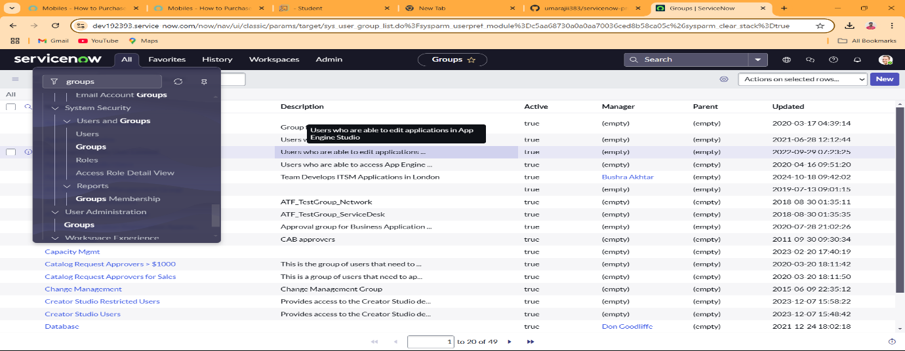

1. **Step 10 :** Fill the following details to create a new group..

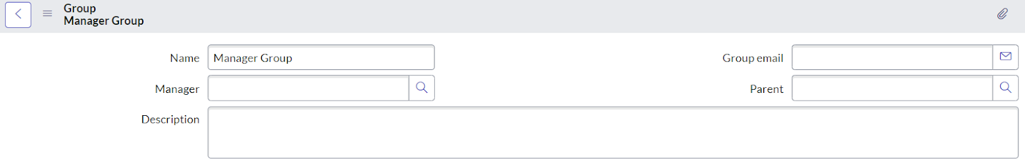

**Step 11 :** Add the user(Jai Prakash) to the Manager Group and click on Save.

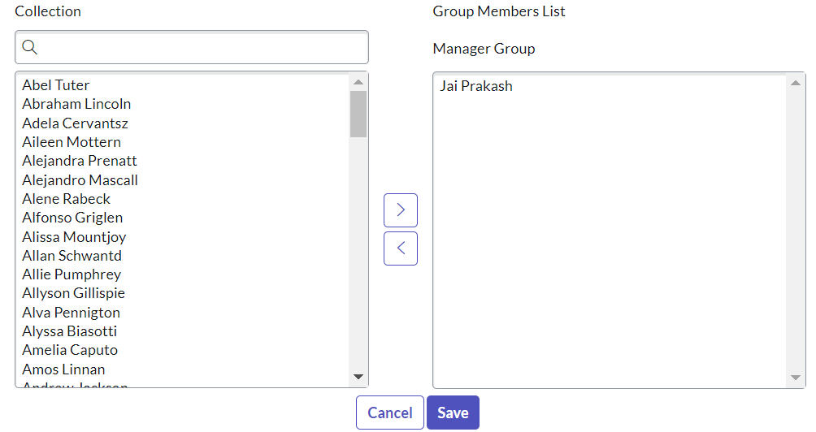

**Step 10 :** open All>> Roles.

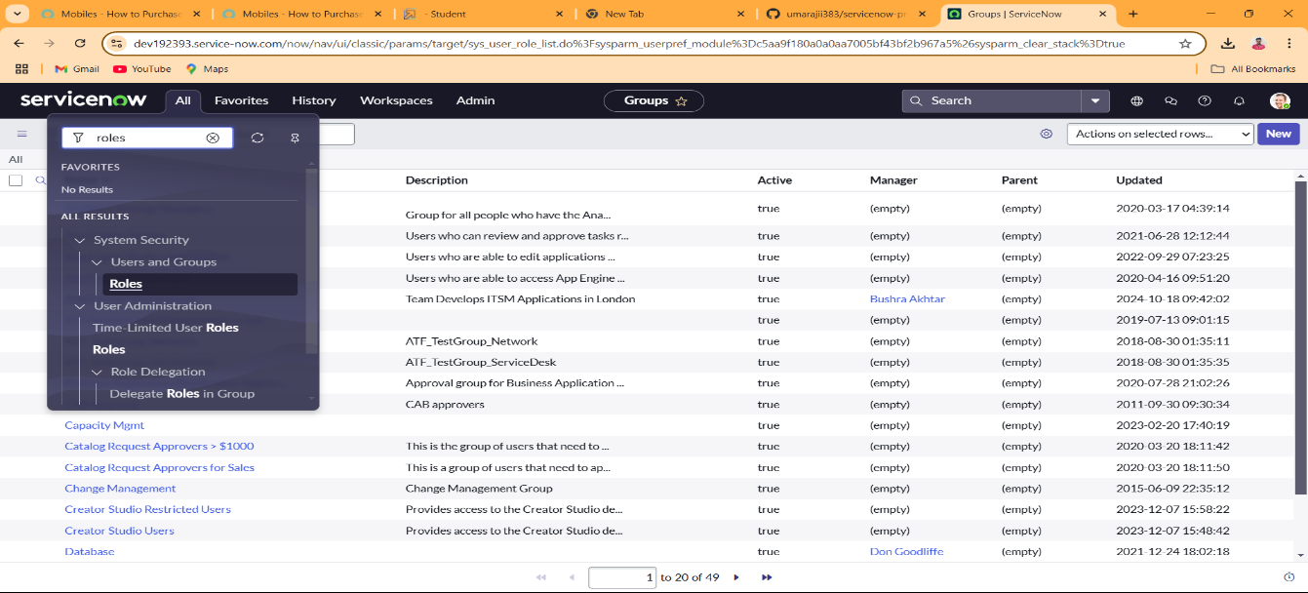

1. **Step 11 :** Fill the following details to create a new role.

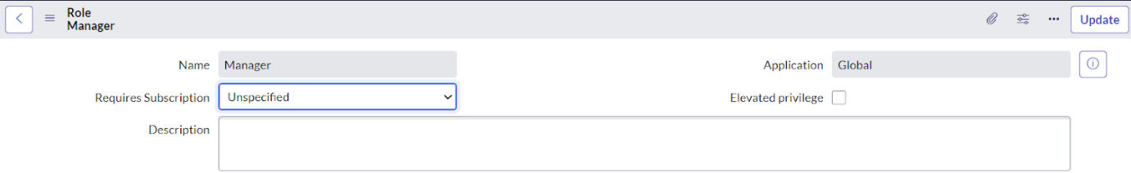

**Step 12 :** Navigate : All>>Knowledge Bases.

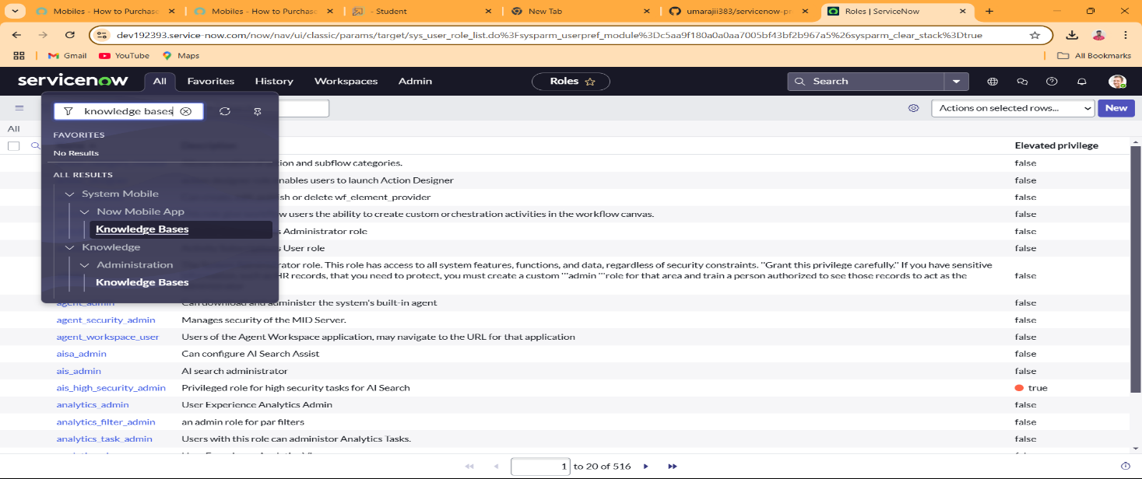

**Step 13 :** Enter the details for knowledge base as:

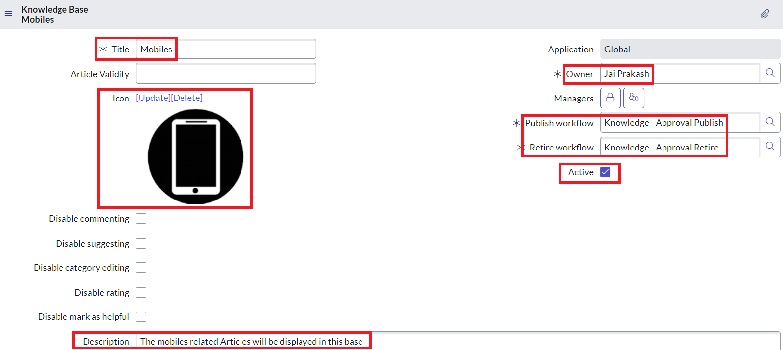

**Step 14 :** All >> My Knowledge Article.

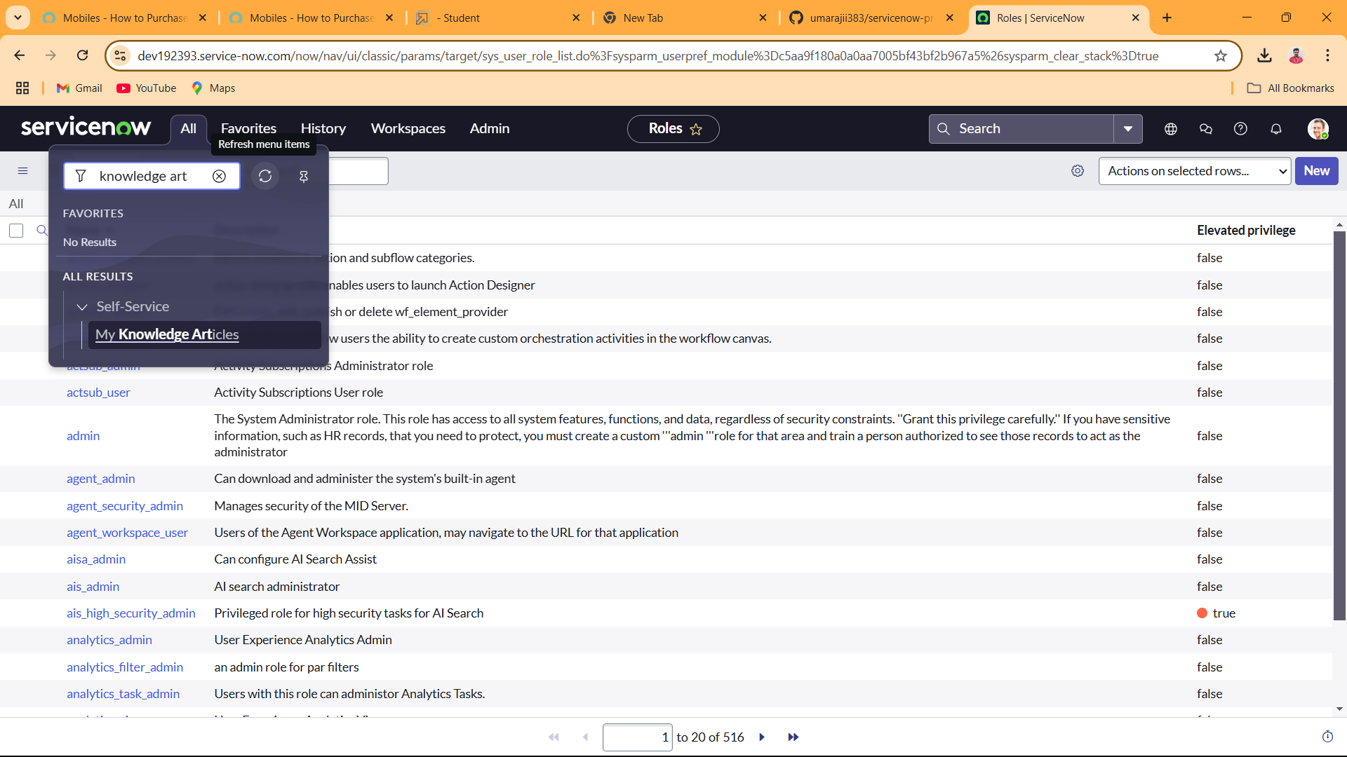

1. **Step 15 :** InArticle Body: Type your Article information.

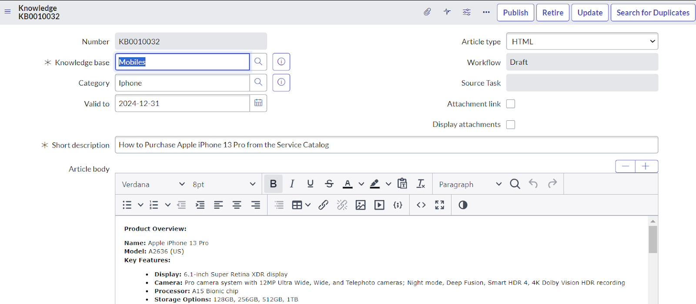

1. **Step 16 :** Click on Edit and add Apple iPhone 13 pro to Related Catalog Items List.

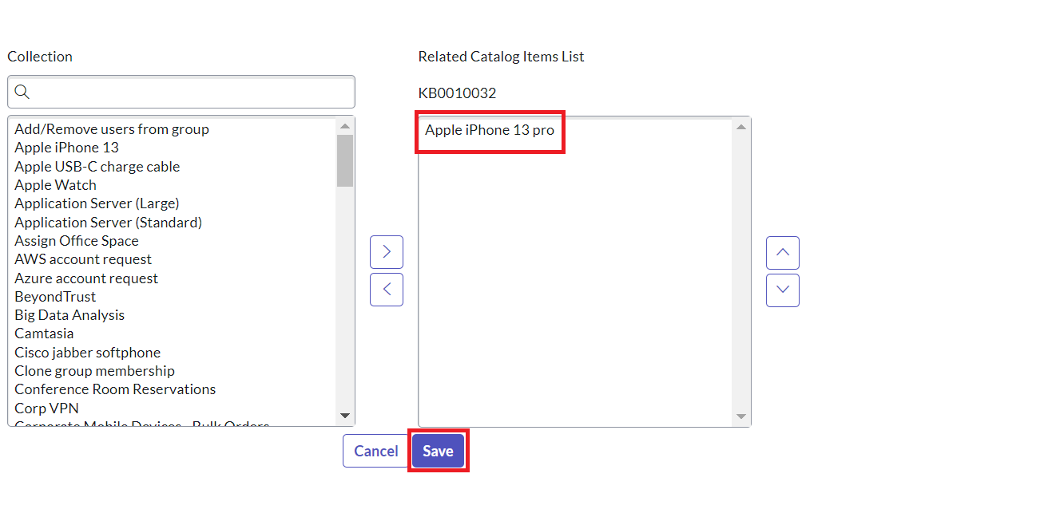

1. **Step 17 :** Under State, you can find Requested. Click on that

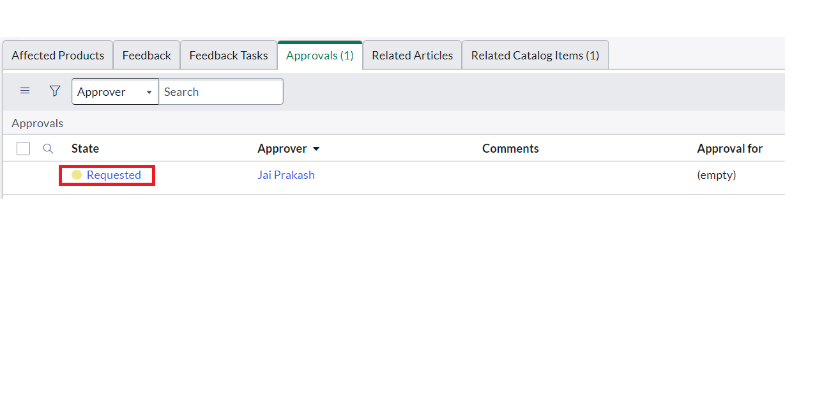

1. **Step 18 :** Approve the Article (To do that change the state to Approved)

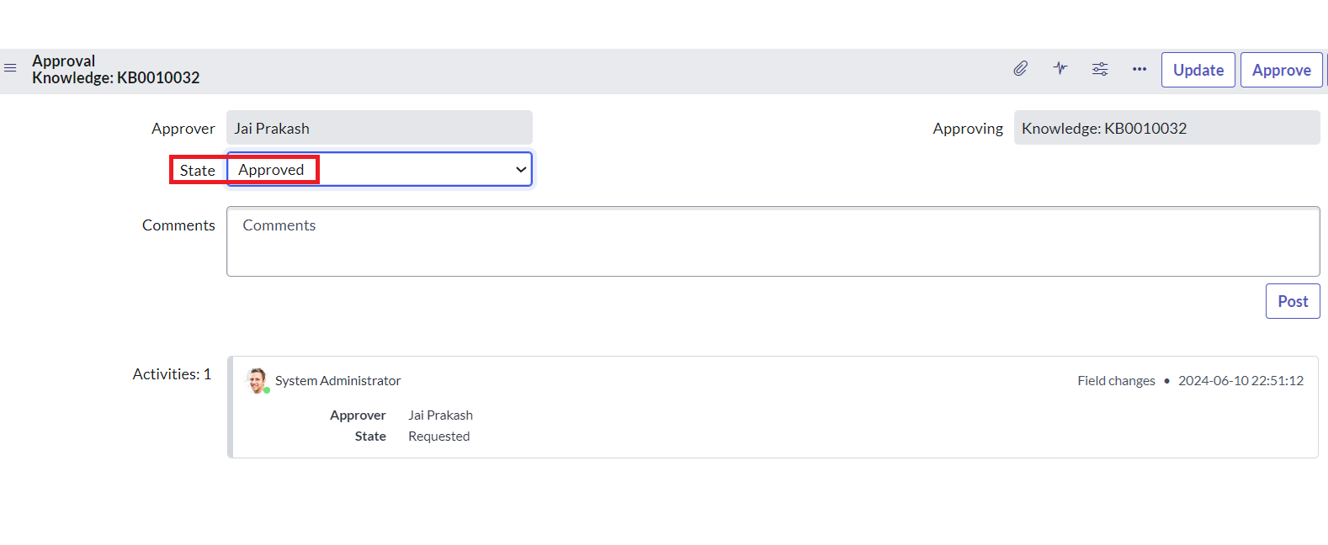

**Step 19 :** Navigate All>portals

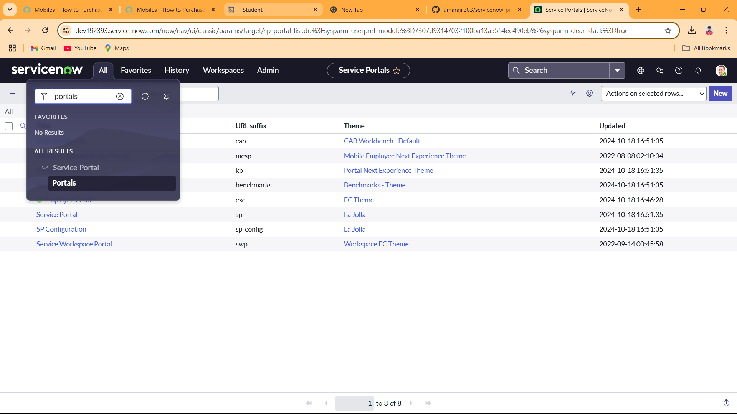

**Step 20** :  Add Mobiles to Knowledge Bases List.

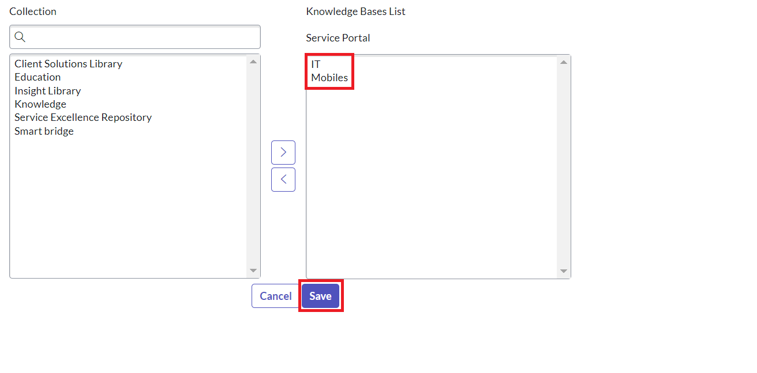

**Step 21**:  To do that Copy the top URL.

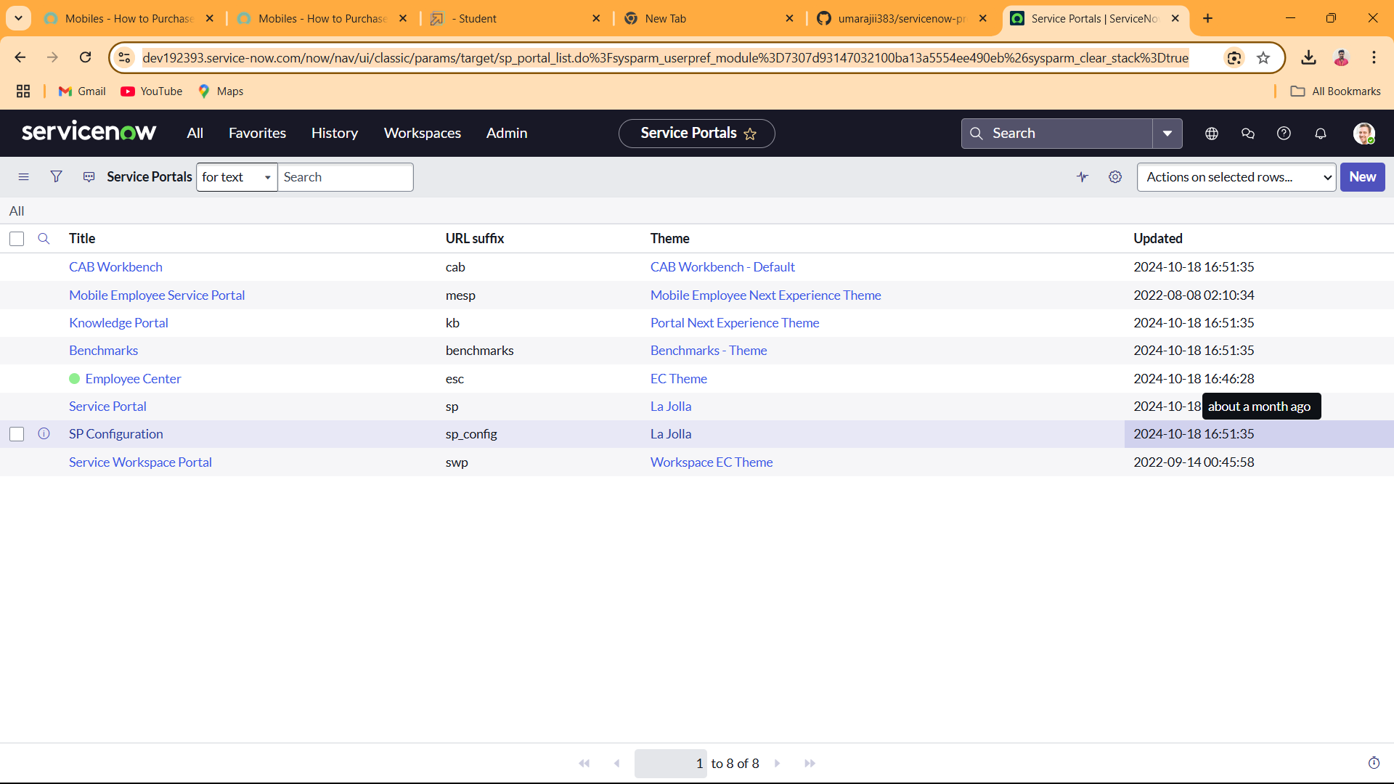

**Step 22**:  To do that Copy the top URL.



**Step 23**: Add sp to the URL last.



**Step 24**: Open Knowledge Bases and in that select Mobiles >> Iphone 13 Pro.

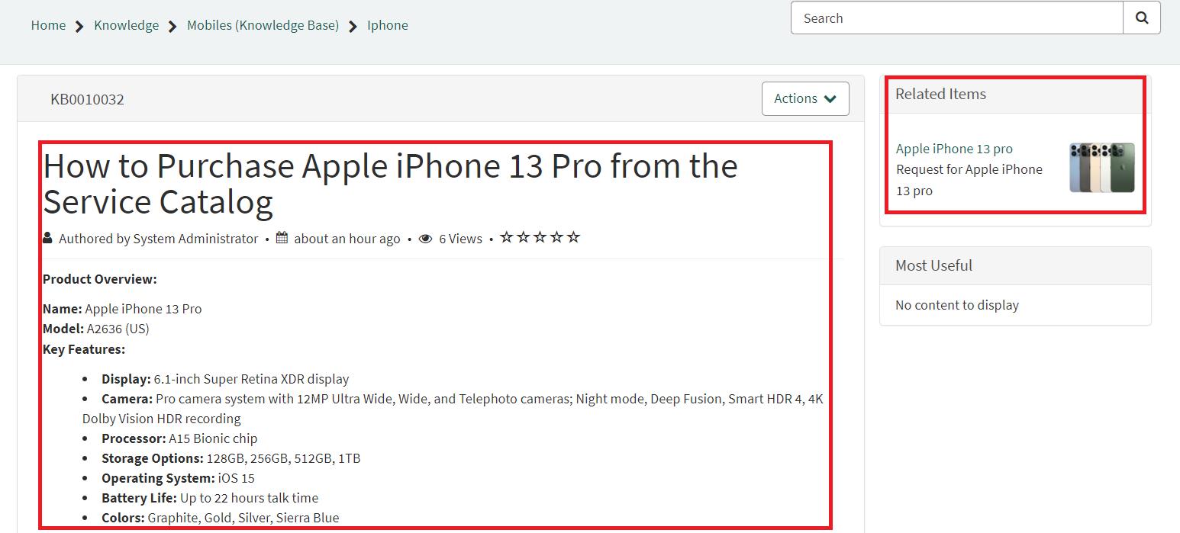

**Conclusion:**

Implementing access control on the ServiceNow Project to create a comprehensive guide for how to purchase Iphone 13 pro and its features, performance etc

This project demonstrates a comprehensive information, instructions, and support related to the products they are interested in purchasing Iphone 13 pro.

Ultimately, this customization not only enhances security by restricting access to sensitive information but also optimizes workflow efficiency, making the ServiceNow environment more tailored and effective for all users involved.